Multiple-choice section

Question 1 [5.1]

The sum of x and 9 can be written using algebra as:

A x + 9 B x – 9 C 9x D ****

Question 2 [5.1]

Joseph has s stickers, Liam has 3 less than Joseph, and Angela has double the amount of stickers that Liam has. How many stickers does Angela have?

A 2s + 3 B 2(s – 3) C 2s – 3 D 

Question 3 [5.1]

The product of two different numbers can be represented by:

A a + b B ab C a – b D a ÷ b ÷ c

Question 4 [5.1]

The pronumerals in the expression y = 3x + 5z + 7 are:

A 3, 5 B x, z C x, y, z D 7

Question 5 [5.1]

Which expression matches the statement below?

‘The difference between a number and 4.’

A n + 4 B 4n C n – 4 D 3n + 1

Question 6 [5.4]

If you substitute w = 5 into h = , h will equal:

A 5 B 2 C 3 D 4

Question 7 [5.6]

A like term for 5a is:

A 5b B abc C 5ab D 7a

Question 8 [5.6]

Which of the following is obtained when 4p + 5p + 6 is simplified?

A 15p B 9p + 6 C 9p – 6 D 4p + 11

Question 9 [5.3]

Choose the correct algebraic rule for the statement below.

‘To get y, multiply x by 3 then take away 5.’

A y = 3x – 5 B y = 3 + x – 5 C y = 3 + x + 5 D y = 

Question 10 [5.4]

If j = 2k + 1 and k = 3, then j is equal to:

A 24 B 6 C 7 D 8

Question 11 [5.4]

If P = 10 – n, which set of values is not true?

A n = 6, P = 4 B n = 5, P = 5 C n = 10, P = 0 D n = 3, P = 8

Question 12 [5.5]

The rule for the following matchstick pattern creating t triangles from m matchsticks is:

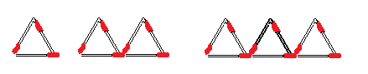

A m = 2t + 3 B m = 3t C t = 3m D t = m + 3

Question 13 [5.7]

Which of the following points is in the first quadrant?

A (3, -6) B (-4, -3) C (-2, 4) D (1, 5)

Question 14 [5.8]

What is the rule linking x and y?

|  |  |  |  |  |
| --- | --- | --- | --- | --- |
| x | 3 | 5 | 6 | 11 |
| y | 7 | 9 | 10 | 15 |

A y = 2x + 1 B y = x + 4 C x = y + 4 D y = 3x – 2

Question 15 [5.9]

Looking at the following graph, which statement is true?

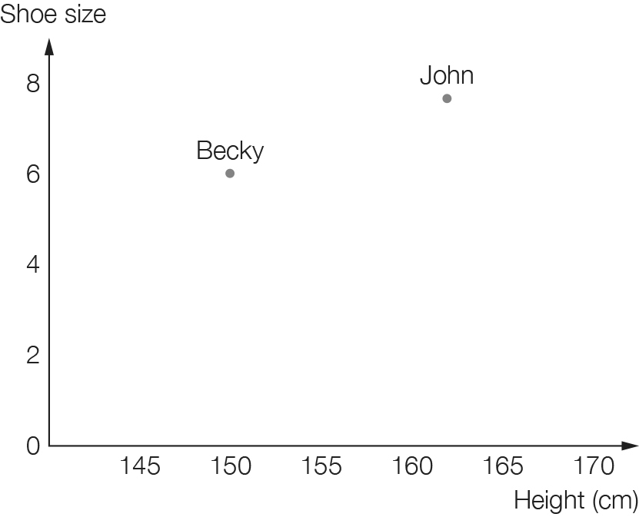

A Becky is taller than John. B John is taller than Becky.

C John shoe size is 9. D Becky's shoe size is larger than John’s.

Multiple-choice total marks: \_\_\_\_ / 15

Short answer section

Question 16 3 marks [5.2, 5.7]

Use words from the list below to complete the following sentences.

constant like terms x-axis relationship y-axis table of values x-axis

(a) The expression 2x + y + 5 contains three \_\_\_\_\_\_\_\_\_\_\_\_\_.

(b) In the expression 2x + y + 5, the ‘5’ is called the \_\_\_\_\_\_\_\_\_\_\_\_\_\_\_\_\_\_.

(c) The point (-7, 0) is on the \_\_\_\_\_\_\_\_\_\_\_\_\_\_\_\_\_\_\_\_\_\_.

Question 17 2 marks [5.2]

Define the term ‘equation’ and give an example.

Question 18 2 marks [5.3]

Explain what a flowchart is and give an example of how they are used in mathematics.

Question 19 1 mark [5.1]

Use algebra to write an expression for the total length of the sides of the triangle below.

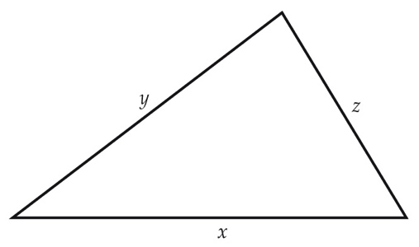

Question 20 3 marks [5.1, 5.6]

Brent has x games. Gaz has five more games than Brent. Use algebra to write:

(a) the number of games that Gaz has

(b) the number of games that they both have altogether. (Simplify your answer).

Question 21 2 marks [5.1]

A rose has 15 petals and a daisy has 8 petals. Write an expression to represent the total number of petals of r roses and d daisies.

Question 22 1 mark [5.1]

If the total number of animals in Diagram 1 can be represented by m. Use algebra to represent the total number of animals in Diagram 2.

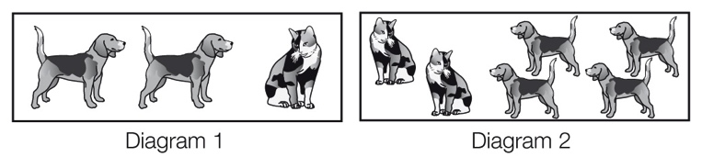

Question 23 2 marks [5.2]

A box with a mass of 2 kg contains five books. The total mass of the box and books is 12 kg. If m is the mass of one book, write an equation to represent the total mass of the box.

Question 24 6 marks [5.3]

y is equal to 3 times x plus 1.

(a) Draw a flowchart for this rule.

(b) Write the rule using algebra.

(c) Complete the following table of values for the rule.

|  |  |  |  |  |
| --- | --- | --- | --- | --- |
| x | 1 | 2 | 3 | 10 |
| y |  |  |  |  |

Question 25 3 marks [5.3]

Write each of these rules in simplest form using algebra.

(a) Divide x by 4 to find y.

(b) To find y, add 1 to x then double your answer.

(c) To find y, multiply x by itself.

Question 26 2 marks [5.3]

Write the algebraic rule shown by the following flowchart.

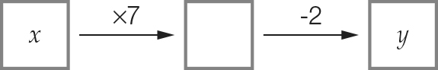 y = \_\_\_\_\_\_\_\_\_\_\_\_\_\_\_\_\_\_\_\_

Question 27 2 marks [5.3]

The following table has only the y-values filled in. Use the flowchart to complete the table.  
(Remember to work backwards.)

|  |  |  |  |  |  |
| --- | --- | --- | --- | --- | --- |
| Macintosh HD:Users:lizwaud:Desktop:PM7_eBook:Batch 1 commenced:Artwork_CORRECTED_041016_Use this:Ch5:PM2e_07_EB_05_FAT_03.jpg | x |  |  |  |  |
| y | 10 | 12 | 16 | 20 |

Question 28 5 marks [5.3]

Lindy spent $50 on tools to make cards. Each card she made cost her $2. The cost for one card is:

$50 + $2 × 1 = $52

(a) Using this information, fill in the table below.

|  |  |  |  |
| --- | --- | --- | --- |
| Number of cards, n | 3 | 5 | 10 |
| Cost to produce the cards, C |  |  |  |

(b) Complete the rule for the cost of making the cards.  
  
C = \_\_\_\_\_ + \_\_\_\_n

Question 29 2 marks [5.4]

Answer true or false for each of the following:

(a) If you substitute a = 2 into b = 3(a + 1) you get b = 9. \_\_\_\_\_\_\_\_\_\_\_\_\_\_\_\_

(b) If you substitute t = 5 into C = 2t – 4 you get C = 21. \_\_\_\_\_\_\_\_\_\_\_\_\_\_\_\_

Question 30 2 marks [5.4]

Use the rule to complete the table of values below.

n = m + 8

|  |  |  |  |  |
| --- | --- | --- | --- | --- |
| m | 2 | 5 | 10 | 12 |
| n |  |  |  |  |

Question 31 2 marks [5.4]

The formula  converts the number of days to the number of weeks.  
What is the value of w if d = 35?

Question 32 4 marks [5.5]

Here is a matchstick pattern of shapes.

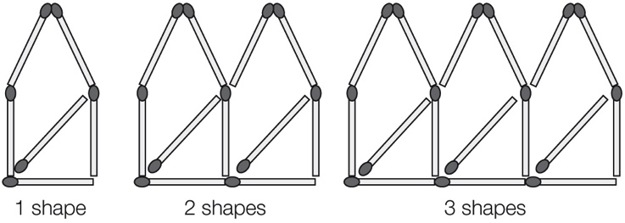

(a) Complete the table below.

|  |  |  |  |
| --- | --- | --- | --- |
| Number of shapes, S | 1 | 2 | 3 |
| Number of matches, M |  |  |  |

(b) Find a general rule that connects the number of matches to the number of shapes.

M = \_\_\_\_\_\_\_\_\_\_\_\_\_\_\_\_\_\_\_\_\_\_\_\_

Question 33 6 marks [5.6]

Simplify each expression where possible by collecting like terms.

(a) 4k + 6k (b) 9t – 3t

(c) 3xy + 5xy (d) 6a + 2a – 4

(e) 6p + 9 + p – 8 (f) 3m + 2m + 4n + 6n + 3

Question 34 3 marks [5.6]

Jim earns $y each week from one job and $x each week from another job. Using algebra, write down how much he earned:

(a) after 1 week

(b) after 3 weeks.

Question 35 6 marks [5.7]

(a) Write the coordinates of each of the points shown below.

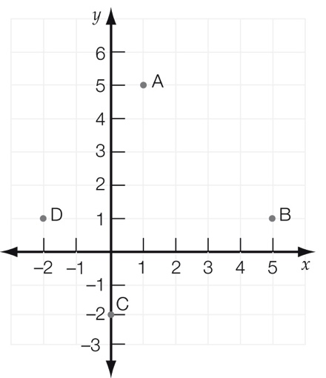

A \_\_\_\_\_\_\_\_\_\_\_\_ B \_\_\_\_\_\_\_\_\_\_\_\_ C \_\_\_\_\_\_\_\_\_\_\_\_ D \_\_\_\_\_\_\_\_\_\_\_\_

(b) In which quadrants are the following points?  
A: \_\_\_\_\_\_\_\_\_\_\_\_\_\_\_\_\_\_\_\_\_\_\_\_\_\_\_\_\_\_\_\_\_\_

D: \_\_\_\_\_\_\_\_\_\_\_\_\_\_\_\_\_\_\_\_\_\_\_\_\_\_\_\_\_\_\_\_\_\_

(c) Which point is on the y-axis?

(d) If point B was shifted 1 unit up and 3 units left, what would its new coordinates be?

Question 36 7 marks [5.8]

(a) Plot the following points on the number plane and draw a straight line passing through all points.  
(1, 2), (2, 4), (3, 6)

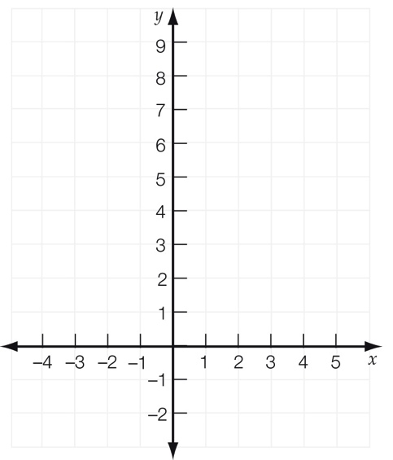

(b) Summarise the set of points in the table below.

|  |  |  |  |
| --- | --- | --- | --- |
| x |  |  |  |
| y |  |  |  |

(c) Write a rule linking the x- and y-values.

(d) Write the coordinates of any other point that is on the line.

Question 37 3 marks [5.9]

The point graph shows the weights and heights of three people: an adult, a baby and a child.

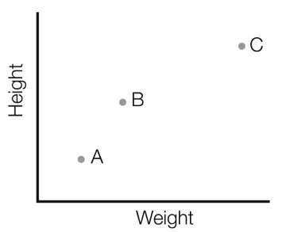

Write the person represented by each point.

A: \_\_\_\_\_\_\_\_\_\_\_\_\_\_\_\_\_\_ B: \_\_\_\_\_\_\_\_\_\_\_\_\_\_\_\_\_\_ C: \_\_\_\_\_\_\_\_\_\_\_\_\_\_\_\_\_\_

Question 38 3 marks [5.9]

Answer true or false for each of the following.

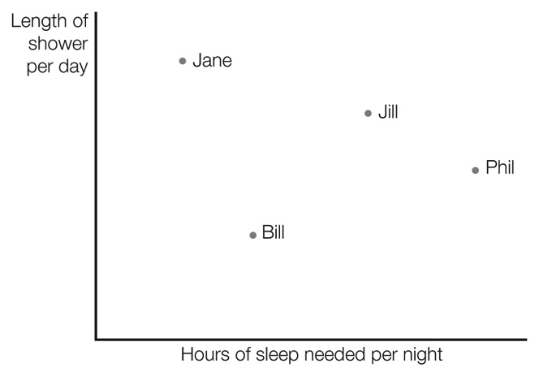

(a) Jane has the longest showers and needs the least sleep.

(b) Phil needs the most sleep and has the shortest showers.

(c) Jill needs more sleep than Bill and has shorter showers than Jane.

Question 39 8 marks [5.9]

Tom begins a hill climb at 10 am. After climbing for 1 hour, he rests for half an hour then continues his climb. He has lunch for 1 hour then returns to the base of the hill.

This information is shown on the travel graph below.

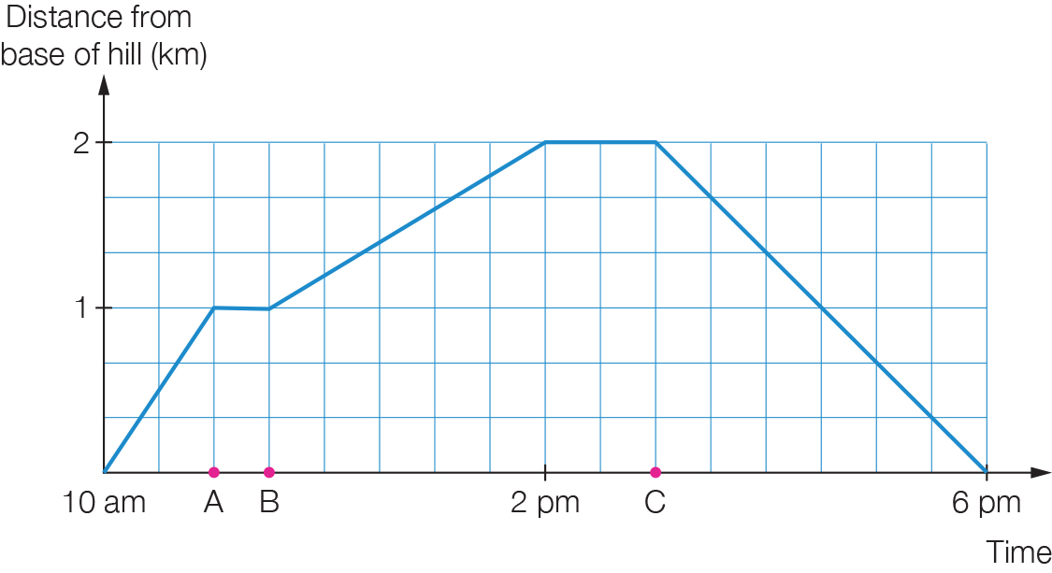

(a) What times are represented by the following letters?

(i) A \_\_\_\_\_\_\_\_\_\_\_\_\_\_\_\_\_

(ii) B \_\_\_\_\_\_\_\_\_\_\_\_\_\_\_\_\_

(iii) C \_\_\_\_\_\_\_\_\_\_\_\_\_\_\_\_\_

(b) How far did Tom hike before he took his first break?

(c) How much time did the hike down the hill take?

(d) What was the total distance travelled?

Short answer total: \_\_\_\_\_\_\_\_\_ / 80

Extended answer section

Question 40 6 marks [5.3]

Bob is moving into his new house. The removalist charges $130, plus $90 for each hour he works. The removalist takes d hours to move the furniture to the new house.

(a) If the removalist took 2 hours to complete the job, how much would it cost Bob?

(b) If C represents the total cost for d hours, write an equation for the total cost.

(c) If Bob paid $400 altogether, how many hours did the removalist take to do the job?

Question 41 10 marks [5.8]

(a) Plot the following points on the number plane and draw a straight line passing through all points. (-3, -2), (-1, 0), (0, 1), (2, 3)

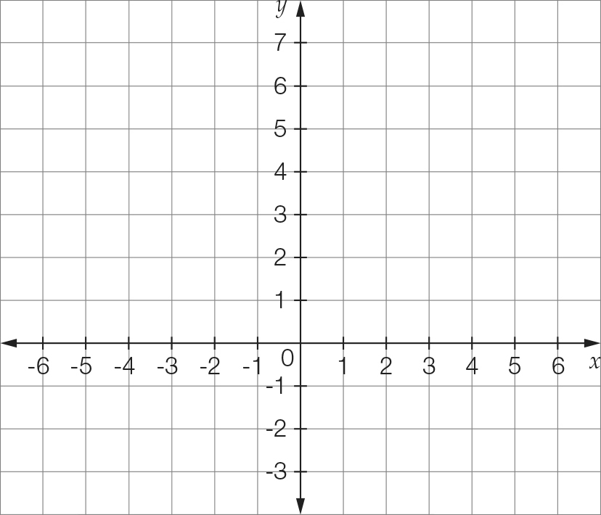

(b) Summarise the set of points in the table below.

|  |  |  |  |  |
| --- | --- | --- | --- | --- |
| x |  |  |  |  |
| y |  |  |  |  |

(c) Write a rule linking the x- and y-values.

(d) If (5, y) is on this line, find the value of y.

(e) Is the point (-1, 1) on this straight line?

Question 42 4 marks [5.9]

Use the graph below to answer the following questions.

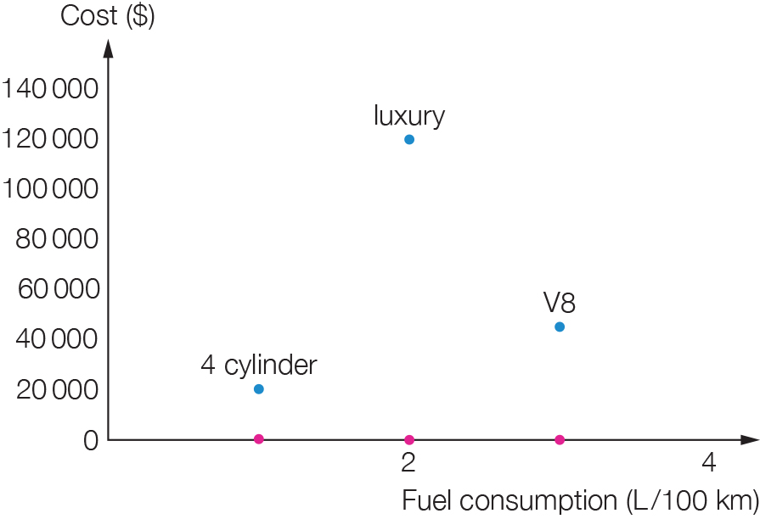

(a) Is there a relationship between the cost of a car and the fuel consumption? Explain your answer.

(b) Which is the cheapest car to drive? Explain your answer.

Extended answer total: \_\_\_\_\_\_\_\_\_ / 20

TOTAL test marks: \_\_\_\_\_\_\_ / 115